

**AN AUTONOMOUS INSTITUTION AFFILIATED TO VTU, BELGAUM, ACCREDIATED by NAAC (‘A+’ Grade) YELAHANKA, BANGALORE-560064**



**A Internship Report on ONLINE JOB PORTAL**

#### BACHELOR OF ENGINEERING IN

**INFORMATION SCIENCE AND ENGINEERING**

##### By

###### K AISHWARYA 1NT20IS072

*Under the Guidance of,*

##### Mr Mohammed AZhar Hussain

Chief Technology Officer Aqmenz Automation Private Limited

Bengaluru-560032



#### DEPARTMENT OF INFORMATION SCIENCE AND ENGINEERING

(Accredited by NBA Tier-1) 2023-24

#### NITTE MEENAKSHI INSTITUTE OF TECHNOLOGY

**(AN AUTONOMOUS INSTITUTION, AFFILIATED TO VTU, BELGAUM)**

**DEPARTMENT OF INFORMATION SCIENCE AND ENGINEERING**

**Accredited by NBA Tier-1**



# CERTIFICATE

Certified that the internship work entitled **ONLINE JOB PORTAL** carried out by Mr./Ms. **K AISHWARYA**, USN **1NT20IS072**, a bonafide student of **Nitte Meenakshi Institute of Technology** in partial fulfillment for the award of Bachelor of Engineering in **Information Science and Engineering** of the Visvesraya Technological University, Belgaum during the year **2023 - 24**. It is certified that all corrections/suggestions indicated for Internal Assessment for progess-I have been incorporated in the Report deposited in the departmental library.

Signature of the HOD

External Viva

Name of the internal and external examiners Signature with date

1. Mr. Prashanth B S
2. Prof. Manjunatha B A

#### NITTE MEENAKSHI INSTITUTE OF TECHNOLOGY

**(AN AUTONOMOUS INSTITUTION, AFFILIATED TO VTU, BELGAUM)**

**DEPARTMENT OF INFORMATION SCIENCE AND ENGINEERING**

**Accredited by NBA Tier-1**



# DECLARATION

I, **K AISHWARYA (1NT20IS072)**, bonafide students of Nitte Meenakshi Institute of Technology, hereby declare that the internship entitled **ONLINE JOB PORTAL** submitted to the Visvesvaraya Technological University, Belgaum during the year 2023-2024 is my original work and the internship has not formed the basis for the award of any other degree, fellowship or any other similar titles.

###### Signature of the Student with Date

Place: Bangalore Date:

# CERTIFICATE LETTER

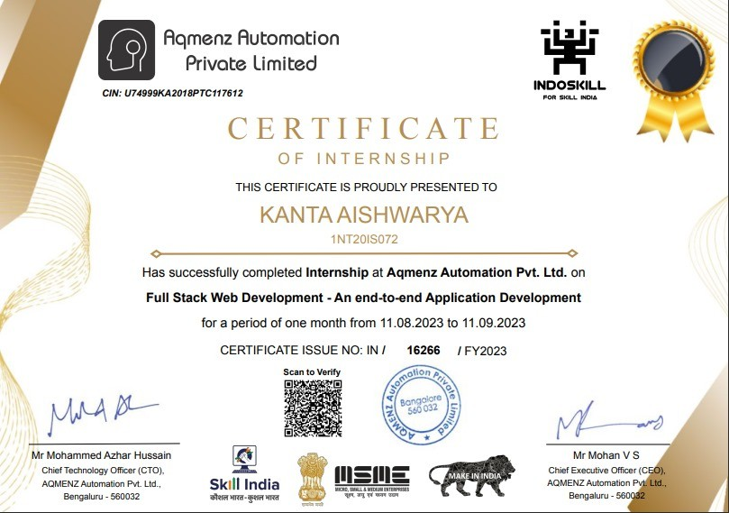

**ABSTRACT**

Job portal service was developed for creating an interactive job vacancy form for candidates. This web application manage updates both from the job seekers as well as the companies. It’s unique development methodology helps in acquiring the client and candidate information and separating them according to the job requirements and vacancies.The online access to it provides details of the job. An employer being registered in the web site has the facility to use the services. Being an authorized user he can publish vacancy details and can search no of Employees on portal and also he can search candidates on basis of the key skill which employee provides on registration.The primary objective is to create a centralized platform where job seekers can search for relevant employment opportunities based on various parameters such as job title, location, industry, and experience level. Additionally, employers can post job vacancies, manage applicant profiles, and streamline the hiring process efficiently.

# ACKNOWLEDGMENT

The satisfaction and euphoria that accompanies the successful completion of Internship would be incomplete without the mention of people who made it possible and whose constant encouragement and guidance has been a source of inspiration throughout the work.

We would like to express our deepest sense of gratitude for our beloved Chief Technology Officer Mr Mohammed AZhar Hussain for providing us a great learning environment. We cannot thank enough Mr.Salman for the continuous efforts in creating a competitive environment in the department and encouragement throughout the course of completion of the Internship.

With profound gratitude, we express our indebtedness to our Web Development Guide Mr. Ravi, whose dedication to the project, Knowledge and references got our job done in the shortest time frame possible. Sir,we would like to sincerely thank you for the quality time you spent with us to clarify our doubts and for guiding us at each and every step toward completion of this Internship.

We are also thankful to the entire Company of Aqmenz Automation Private Limited for Co- Operation and Suggestion without which this Internship would not have been a successful one. We also thank all friends who directly or indirectly helped us a lot in this project completion.

## Contents

List of Figures 1

1. Introduction 2
   1. Issues and Challenges in Regestration 2
   2. Problem Statement 3
   3. Objective 3
   4. Organization Of Report 3
2. Literature Review 4
   1. Importance of Job Portals 5
   2. Project Feasibility Study 5
      1. Technical Feasibility 5
      2. Economical Feasibility 5
      3. Operation Feasibility 6
3. Daily Activities/Log 7
4. Requirements Specification 8
   1. Functional Requirements 8
      1. Hardware 8
      2. Software 9
   2. Non-Functional Requirements: 9
5. Methodology and System Design 10
   1. Methodology: 10
   2. System Design: 11
6. Testing 14
7. Results 18
8. Conclusion and Future Scope 20

Bibliography 21

## List of Figures

* 1. Methodology 10
  2. Use Case Diagram 12
  3. Context-Level Data Flow Diagram 13
  4. Test Cases of Figure:1 15
  5. Test Cases of Figure:2 16
  6. Test Cases of Figure:3 17
  7. Home Page 18
  8. Admin Page 19

## Chapter 1 Introduction

Now a day, we know that searching of jobs is so difficult in proficient areas the portal developed for the providing the simple and good job searching. With the help of this portal easily the job seeker can submit their resume and get the lot of opportunity of the job related to their profile. And by this website the companies or employer can also find the good and well profiled resume.

### Issues and Challenges in Regestration

* + - **Data Validation:** Ensuring that users enter accurate and complete information is crucial for maintaining data integrity and preventing fraudulent registrations. Implement proper validation checks to verify user input, such as email format, phone number validity, and password strength.
    - **Duplicate Registration:**Preventing users from creating multiple accounts with different email addresses or usernames is essential to avoid spam and maintain user authenticity. Implement a unique identifier, such as a user ID, to track individual registrations and prevent duplicates.
    - **Email Verification:** Ensuring that users have valid email addresses is crucial for com- munication purposes, password recovery, and account activation. Implement email ver- ification procedures, such as sending a verification link or code to the registered email address.
    - **User Data Privacy:** Implement secure data storage practices, obtain user consent for data collection, and provide clear privacy policies.
    - **User Experience:** Designing a user-friendly and intuitive registration process is essential for attracting and retaining users. Provide clear instructions, minimize required fields, and offer a seamless registration experience.

### Problem Statement

Developed an online job portal that effectively connects job seekers with suitable employment opportunities and assists employers in finding qualified candidates.

### Objective

The online job Portal System that is to be developed provides the members with jobs informa- tion,online applying for jobs and many other facilities. This system provides service to the job applicants to search for working opportunities.Job Portal will allow job provider to establish one to one relationships with candidates.This Portal will primarily focus on the posting and management of job vacancies.This system is designed such that ultimately all vacancies will be posted online and would offer employers the facilities to post their vacancies online. It helps to review and manage the resulting applications efficiently through the web. Employer can also find the resume according to key skill in very less amount of time.

### Organization Of Report

Report is organised in following way:

* + - **C**hapter 2 : Contains literature review
    - **C**hapter 3 : Contains requirement specification
    - **C**hapter 4 : Contains framework methodology and the system design which we are using in proposed project
    - **C**hapter 5 : Implementation of our project and the component used in our project
    - **C**hapter 6 : Testing
    - **C**hapter 7 : Result and Discussion
    - **C**hapter 8 : Conclusion and future scope

## Chapter 2 Literature Review

Job Procurement: Old and New Ways Job seeking usually involves different ways to look for jobs such as through personal contacts, direct telephone calls to employers, job agency office, scanning online job listings, etc. Before the Internet, became widely uses as a method of seeking jobs, job seekers spent a lots of time using various methods to look for job openings. Today, job seekers use online methods which are very convenient and save a lot of time. Galanaki lists the following methods to be the traditional (old) ways for recruitment:

1. Employment recruitment agencies
2. Job fairs
3. Advertising in the mass media such as newspapers
4. Management Consultants
5. Advertisement in television and radio
6. Existing employee contacts
7. Schools colleges or universities students services department
8. Workers or professional referrals

These old job seeking methods are too slow, stressful, challenging and also lack quality. In ad- dition, the applicants have to consider the cost and the amount of time to get the information they need, and other preparations they have to make. Finding all available job vacancies is a main step at in the job-seeking process. The Internet is now a powerful tool that jobseekers can use. Today, there are many sites that advertise job positions to be filled by people with certain skills in various fields. The Internet plays an important role in the area of human resource

planning and development. Most planning and development organizations are now using com- puter technology and the Internet for staff recruitment. It should be noted that although the Internet has facilitated the process of job-seeking, it has not replaced the traditional methods, completely.

### Importance of Job Portals

In the age of technology, the Internet has become the main source of information for jobseek- ers.Large corporations, Institutions, and universities include information on career Prospects on their websites. According to a survey,70 percentage of the workforce uses websites or portals on the Internet to Search for jobs in France. These websites or portals provide search engine to access information on job opportunities.

### Project Feasibility Study

##### Technical Feasibility

Technical feasibility study is concerned with specifying equipment and software that will suc- cessfully satisfy the user requirement; the technical needs of the system may vary consider- ably.The facility to produce outputs in a given time. Our project is a web based application which is based on client-server based application. In this application every page as output is render from server to client so it is necessary that the page should be rendered in time.For this I have avoided more and more code in the page load event.

##### Economical Feasibility

Economical feasibility is the measure to determine the cost and benefit of the proposed system.A project is economical feasible which is under the estimated cost for its development.These benefits and costs may be tangible or intangible. Job Portal is the cost-effective project in which there is less possibility of intangible cost so there is no difficulty to determine the cost of the project.

##### Operation Feasibility

Operation feasibility is used to check whether the project is operationally feasible or not.Our project is mainly different from the other system because of its web-support feature.So the measure for operational feasibility is something different from other system. Generally the operational feasibility is related to organization aspects.The change determination is as such that early product were either a man or group of men or the jobs based manual but now a day with the advent of Internet technology.

## Chapter 3

**Daily Activities/Log**

* + - * **Week-1:** Planning and Setup. Defined project scope, objectives, requirements and set up project management tools and communication channels.
      * **Week-2:**Front-End Development Set up the front-end framework and initial project struc- ture and began coding the basic structure of the website.
      * **Week-3:** Back-End Development Using PHP and MYSQL fetching detailed information of job seekers .
      * **Week-4:** Testing and Optimization. Conducted extensive testing for functionality, us- ability, performance and optimized the code for performance and speed.

## Chapter 4

**Requirements Specification**

### Functional Requirements

User Registration and Management :

Users should be able to register as job seekers or employers. Job seekers should be able to create a profile that includes their resume, contact information, and skills.

Job Search and Application :

Job seekers should be able to search for jobs by keyword, location, industry, and other criteria. Job seekers should be able to view job postings and apply for jobs online.

Employer Tools :

Employers should be able to create a company profile that includes their company informa- tion, logo, and culture. Employers should be able to post jobs to the portal and manage their job postings. There are two types of Functional Requirement mentioned in the Section

##### Hardware

The system requires the following hardware:

* + - * RAM: 1 GB (further increase that as per requirement.)
      * Hard Disk: 80 GB (further increase that as per requirement)
      * Mouse: Any Normal Mouse.
      * Keyboard: Any window Supported Keyboard.

##### Software

The system requires the following Software:

* + - * Database Server : Microsoft SQL Server
      * Web Server : Internet Information Server
      * Technologies : HTML,CSS,ASP.NET,JavaScript,JQuery

### Non-Functional Requirements:

Non-functional requirements(NFRs) define the overall quality attributes of a software system, while functional requirements(FRs) specify the specific behaviors or capabilities of the system. In the context of an online job portal using PHP and MySQL,NFRs focus on aspects like performance, security, usability, maintainability,and scalability.

* Performance:

The job portal should be able to handle a large number of concurrent users without experiencing significant performance degradation.

* Security:

User authentication and authorization mechanisms should be robust to prevent unautho- rized access to sensitive information.

* Usability:

The user interface should be intuitive and easy to navigate, catering to both tech-savvy and non-technical users.

* Maintainability:

The codebase should be well-structured, documented, and commented to facilitate future modifications and bug fixes.

* Scalability:

The system architecture should be designed to accommodate a growing user base and in- creasing data volume. The database should be able to handle expanding datasets without compromising performance or integrity.

## Chapter 5

**Methodology and System Design**

### Methodology:

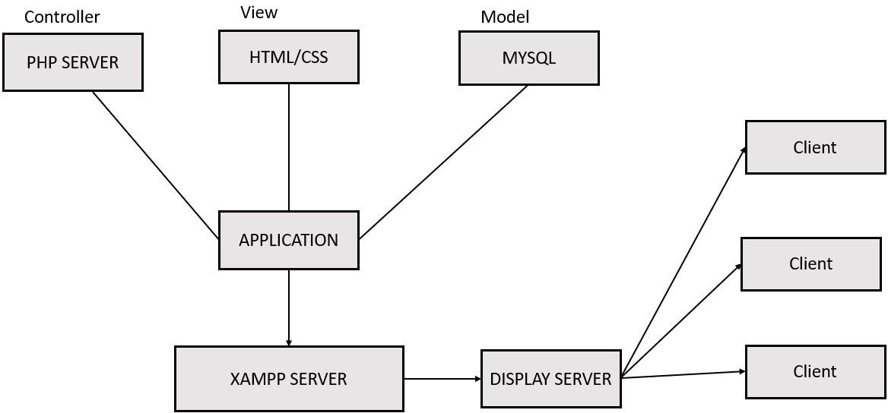

Figure 5.1: Methodology

The Following Figure 5.1 shows Methodology of Online job portal using PHP and MYSQL

### System Design:

The online job portal is designed using the Model-View-Controller (MVC) pattern, which sep- arates the application into three main components:

* + - **Model:** The model represents the data and business logic of the application. It interacts with the database to store, retrieve, and manipulate data.
    - **View:** The view is responsible for presenting the data to the user in a user-friendly interface. It generates HTML content based on the data provided by the model.
    - **Controller:** The controller acts as the intermediary between the model and the view. It handles user interactions, processes requests, and updates the model accordingly.

The use of PHP as the server-side scripting language allows for efficient data handling, dynamic content generation, and secure user authentication. MySQL, as the RDBMS, provides a robust and scalable platform for storing and managing user data, job postings, and application records.

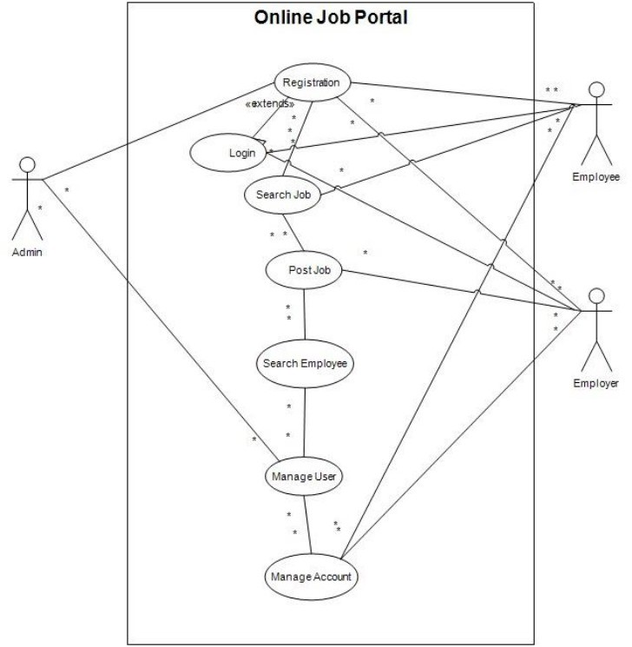

Figure 5.2: Use Case Diagram

The Following Figure 5.2 shows the use case diagram of admin page and login page and search job ,post job ,search employee,manage user,manage account,and also employee and employer page

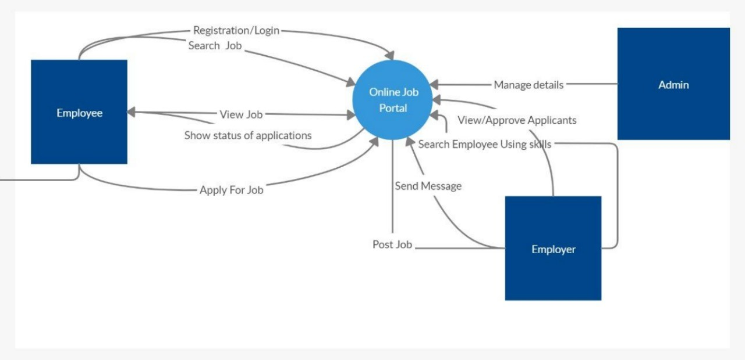

Figure 5.3: Context-Level Data Flow Diagram

The Following Figure 5.3 shows the Context-Level Data Flow Diagram of System Design

/Block Diagram of System Design where we can see the status of applications and registration.

## Chapter 6 Testing

* Job Seeker ID

Test Case 1: Valid Job Seeker ID

Steps: Job seeker logs in to their account. System displays job seeker’s profile information, including their ID. Verify that the displayed job seeker ID matches the expected value.

Test Case 2: Invalid Job Seeker ID

Steps: Enter an invalid job seeker ID into the login form. System displays an error message indicating that the ID is invalid. Verify that the error message is displayed correctly.

* Employer ID

Test Case 3: Valid Employer ID

Steps: Employer logs in to their account. System displays employer’s profile information, including their ID. Verify that the displayed employer ID matches the expected value.

Test Case 4: Invalid Employer ID

Steps: Enter an invalid employer ID into the login form. System displays an error message indicating that the ID is invalid. Verify that the error message is displayed correctly.

* Job Posting ID

Test Case 5: Valid Job Posting ID

Steps: Access the job posting page for a specific job opening. System displays the job posting details, including the job posting ID in the URL. Verify that the job posting ID matches the expected value.

Test Case 6: Invalid Job Posting ID

Steps: Enter an invalid job posting ID into the URL. System displays an error message indicating that the job posting does not exist. Verify that the error message is displayed correctly. Application ID

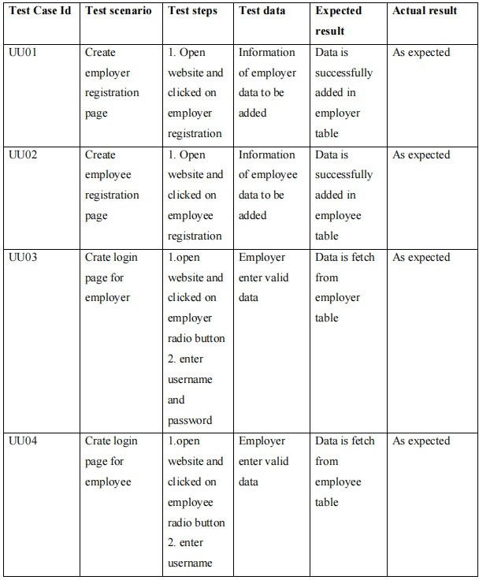

Figure 6.1: Test Cases of Figure:1

The Following Figure 6.1 shows the scenarios of employer registration and employee registration and login page for employer also login page for employee with various ID.

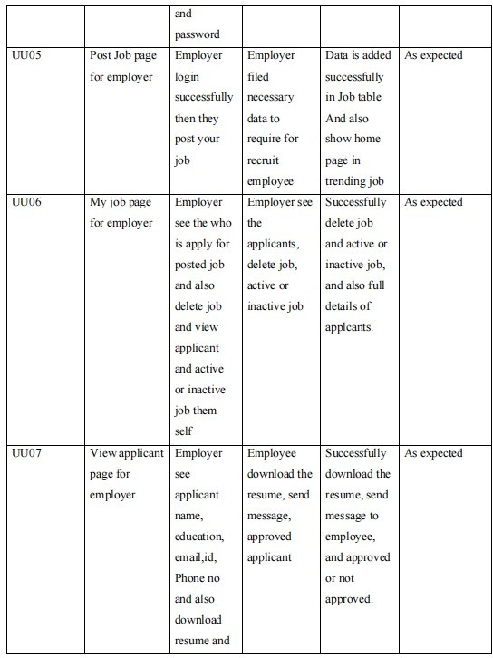

Figure 6.2: Test Cases of Figure:2

The Following Figure 6.2 shows the scenarios of Post Job page for employer and My Job page for employer and also View applicant page for employer with various ID.

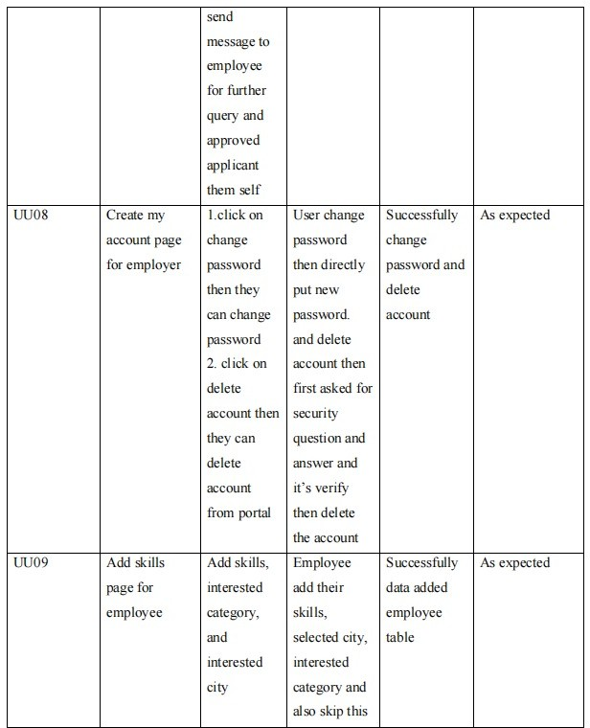

Figure 6.3: Test Cases of Figure:3

The Following Figure 6.3 shows the scenarios of Creating account page for employer and adding skills page for employee with various ID.

## Chapter 7 Results

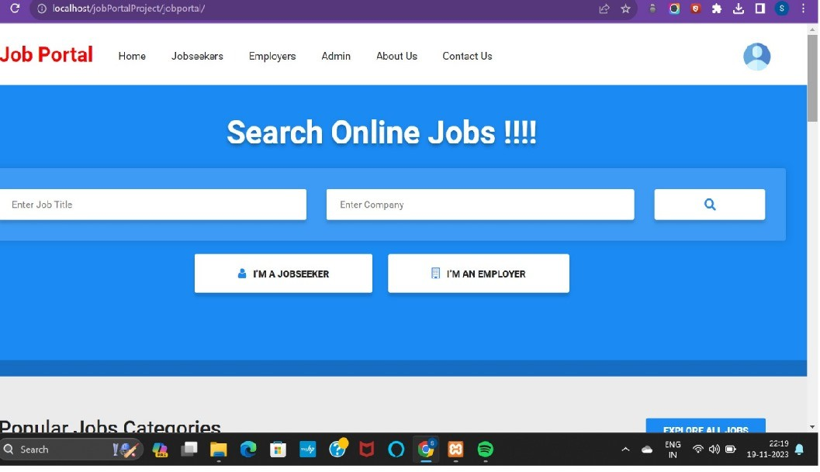

Figure 7.1: Home Page

The following figure 7.1 shows the home page of an online job portal:where we have an Job Title and also we can enter company name as a Job Seeker for applying to the Jobs and also as an employee you can login to the account

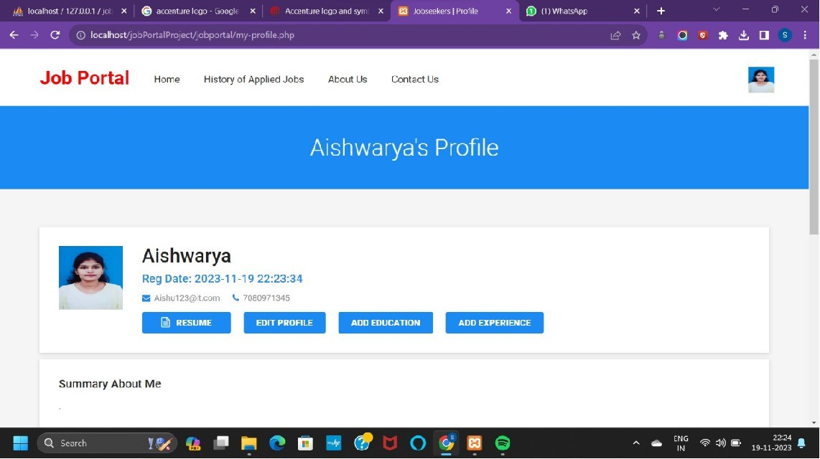

Figure 7.2: Admin Page

The following figure 7.2 shows the Admin Page of Job seeker and also information of Education and Experiences and Editing the profile and also adding the mobile number and the email address and profile picture and attaching the Resume.

## Chapter 8

**Conclusion and Future Scope**

It has been a great pleasure for me to work on this exciting and challenging project. This project proved good for me as it provided practical knowledge of not only programming in ASP.NET web based application and no some extent Windows Application and SQL Server, but also about all handling procedure related with online job portal. It also provides knowledge about the latest technology used in developing web enabled application and client server technology that will be great demand in future. This will provide better opportunities and guidance in future in developing projects independently. As of Indian market, there is ample opportunities for the job portal sites, as more and more number of educated and skilled young people are coming out each and every year. Also, as the growth rate of India is zooming to be at a healthy rate over 7 percentage, so it is boom time for corporate also.So, more and more number of lucrative careers will be available for the job seekers. So, it is now the right period for the job portal sites to think out of the box, and to make most of the opportunities available.

## Bibliography

1. Lerdorf, R., Burton, K. (2016). Developing Web applications with PHP and MySQL (6th ed.). O’Reilly Media, Inc.
2. Welling, L., Thomson, L. (2017). PHP and MySQL web development (8th ed.). Pearson Education, Inc.
3. Beighley, L., Turner, M. (2009). Head first PHP and MySQL (2nd ed.). O’Reilly Media, Inc.
4. Gupta, R. K., Gupta, S. K. (2012). Designing and developing an online job portal using PHP and MySQL. International Journal of Computer Applications, 9(2), 1-8.
5. Mishra, P. K., Jena, S. K. (2013). An efficient approach for job search and recommen- dation in online job portals. International Journal of Computer Science and Information Technology, 6(2), 239-242.
6. Patil, S. B., Patil, K. S. (2014). Security issues and solutions for online job portals. International Journal of Computer Science and Applications, 7(4), 44-49.